Nome: ______________________________ Data: ___________________

Imagina uma história para as imagens e pinta:

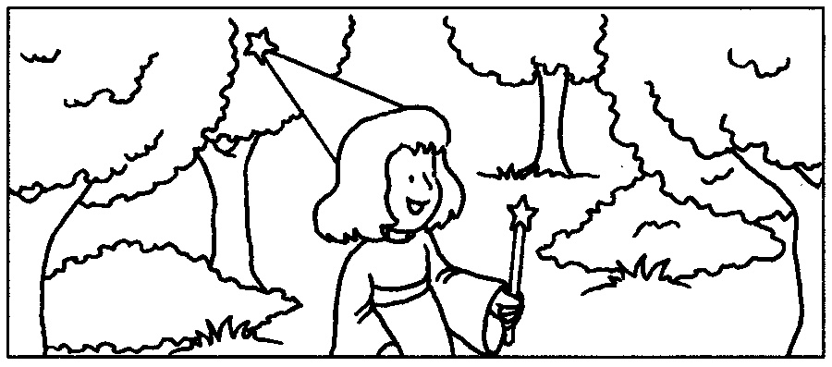 | 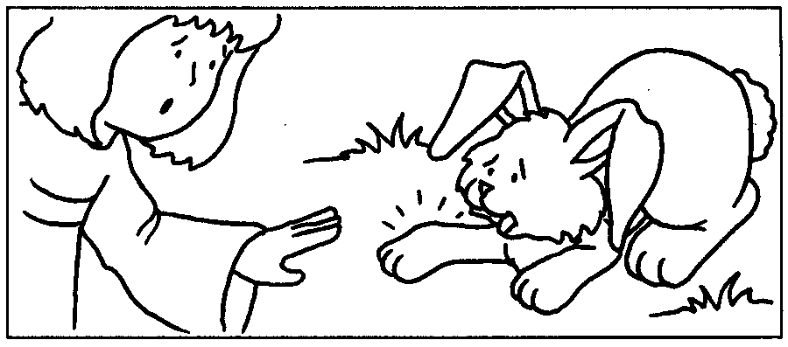
____________________________  ____________________________  ____________________________  ____________________________  ____________________________  ____________________________ | ____________________________  ____________________________  ____________________________  ____________________________  ____________________________  ____________________________
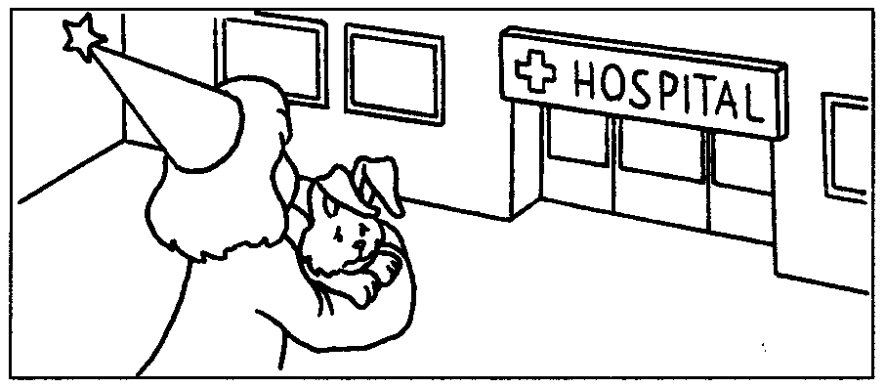 | 
                      

